IEMI Website Design Document

Contents

1 General Information 4

1.1 Changes to Index Structure 4

1.2 Nav Bar 4

1.3 Database 4

2 Page 1 - Animated Landing Page 4

3 Page 2 - New Home Page 4

3.1 Information to display on hover 4

4 Page 3 – Explore Index 7

5 Page 4 – State Profile 7

5.1 State Statistics 7

5.2 IEMI Rank 7

5.3 Themes 7

5.4 Indicators Rank and Score 8

5.5 Navigation Pane 9

5.6 Transport Electrification Progress – Outcomes 9

5.7 Transport Electrification Progress – Initiatives 10

5.8 Transport Electrification Progress – Purchase Incentives 10

5.9 Units of electricity at cost of petrol 11

5.10 EV Research and Innovation Theme 11

5.11 EV Research and Innovation Theme - Outcome 11

5.12 EV Research and Innovation Theme – Initiatives 12

5.13 Charging Infrastructure Readiness – Outcomes 12

5.14 Charging Infrastructure Initiatives 12

5.15 Total Renewable Energy and its share 13

5.16 Power deficit 13

5.17 Highlights and USPs 14

5.18 Recommendation section 14

6 State Comparison Page 15

6.1 Selection 15

6.2 IEMI Score Comparison Summary 15

6.3 IEMI Score Summary sticky bar 15

6.4 IEMI Theme Score Comparison 16

6.5 Navigation Pane 17

6.6 Transport Electrification Progress - Outcome 17

6.7 Transport Electrification Progress - Initiatives 18

6.8 Transport Electrification Progress 18

7 Tools and Analysis Page 19

7.1 Layout 19

7.2 Total cost of ownership 19

7.3 Manufacturing Units 20

7.4 Electric Vehicle Market Insights 20

7.5 Electric Vehicle Charging Tools 21

7.6 E-Buses in STUs 22

8 Downloads 23

9 About the index 23

# General Information

## Changes to Index Structure

1. The Stakeholders have requested to remove geographical groups in the index.
2. The Stakeholders have requested to remove EV Manufacturing Capacity and related indicators. Hence the EV Industry Status has been renamed as **‘EV Research and Innovation’**.
3. Changes related to the above-mentioned points are explained in the respective pages.

## Nav Bar



1. The Navbar UI colour is updated.
2. The Nav Bar should be on the top of the new home page showing the index structure as well.
3. The current homepage icon in the nav bar can be linked to the new home page.

## Database

1. Geographical group shall be removed from the database.
2. Two indicators are added to the database.
   1. Power Gap
   2. R&D Initiatives.

# Page 1 - Animated Landing Page

1. Since the IEMI logo unit is hiding the traffic signal and its animation. Traffic lights can be moved to left (outside the logo unit).
2. Logo unit can be a little opaquer. Now, we can see the elements moving behind the logo unit distracting the logo.
3. Please attempt some movement with the people, like hand movement for man standing near charging station.
4. We can try to animate a couple more vehicles of the left bottom road.
5. The whole width of the road shall be used for animation.

# Page 2 - New Home Page

1. The Nav Bar should be on the top of the new home page showing the index structure.
2. The current homepage icon in the nav bar can be linked to the new home page.
3. The logo unit shall be used to move to the explore index page.
4. Clicking on any of the themes shall take us to respective theme selected in the explore index page.
5. On hovering the themes and indicators. Please display one-line definitions of the themes and indicators. Information to display showed in 4.1

## Information to display on hover

The table below displays text for info icons and cards. Info icon, when clicked/hovered shall display information on index, theme or indicators. The text for info icon is captured below.

| **S** | **IEMI/Themes/Indicators** | **HOVER TEXT** |
| --- | --- | --- |
| **THEMES** | | |
| 2 | Transport Electrification Progress  (Type: Theme)  Info icon – Theme is a sub-domain of the Index which is driven by state-specific policies, incentives, regulations, and processes. Themes are further composed of performance indicators. | Evaluates the pace of EV adoption and offers a snapshot of government initiatives. |
| 3 | Charging Infrastructure Readiness  (Type: Theme) | Evaluates public charging infrastructure availability and development. |
| 4 | EV Research and Innovation Status  (Type: Theme) | Assesses the innovation and R&D landscape for e-mobility. |
| **OUTCOME INDICATORS** | | |
| 5 | Private Electric Vehicle Adoption Rate  Theme: Transport Electrification Progress  Type: Outcome Indicator  Info icon - Outcome indicators are performance metrics of a state that emerge as a result of one or more initiatives undertaken by the state. | Share of EVs among private vehicle registrations. |
| 6 | Commercial Electric Vehicle Adoption Rate  Theme: Transport Electrification Progress  Type: Outcome Indicator | Share of EVs in commercial vehicle registrations. |
| 7 | EV Startups  Theme: EV Research and Innovation Status  Type: Outcome Indicator | Total number ofe-mobility relatedstartups, normalized with Gross State Domestic Product (GSDP). |
| 8 | EV to EV Charger Ratio  Theme: Charging Infrastructure Readiness  Type: Outcome Indicator | Number of EVs per public EV charger. |
| **ENABLER INDICATORS** | | |
| 9 | Governance Initiatives  Theme: Transport Electrification Progress  Type: Enabler Indicator  Info icon - Enabler indicators are performance metrics that capture a state’s policy and governance initiatives, and impact the performance of outcome indicators. | Strategic initiatives to plan, regulate and accelerate EV adoption. |
| 10 | Purchase Incentives  Theme: Transport Electrification Progress  Type: Enabler Indicator | Financial incentives to catalyse EV demand by reducing upfront cost. |
| 11 | Transition Incentives  Theme: Transport Electrification Progress  Type: Enabler Indicator | Financial incentives to encourage retrofitting and scrapping of ICE vehicles. |
| 12 | Operational Support Initiatives  Theme: Transport Electrification Progress  Type: Enabler Indicator | Financial and non-financial incentives to prioritize EVs and reduce their operating costs. |
| 13 | Fuel Price Parity  Theme: Transport Electrification Progress  Type: Enabler Indicator | Cost efficiency of EV electricity tariffs versus fossil fuel prices. |
| 14 | Capital Subsidies for Charging Infrastructure  Theme: Charging Infrastructure Readiness  Type: Enabler Indicator | Financial incentives to reduce the capital cost of EV charging infrastructure. |
| 15 | Charging Infrastructure Development Initiatives  Theme: Charging Infrastructure Readiness  Type: Enabler Indicator | Incentives and measures to expedite the roll-out of public chargers. |
| 16 | Building Byelaws for Charging  Theme: Charging Infrastructure Readiness  Type: Enabler Indicator | State regulations to mandate the integration of EV charging infrastructure in buildings. |
| 17 | Share of Renewable Energy Generation Capacity  Theme: Charging Infrastructure Readiness  Type: Enabler Indicator | Share of renewables in the total installed electricity generation capacity. |
| 18 | Power Availability  Theme: Charging Infrastructure Readiness  Type: Enabler Indicator | Gap between power demand and power supply. |
| 19 | R&D Initiatives  Theme: EV Research and Innovation Status  Type: Enabler Indicator | State actions to promote R&D through financial and non-financial measures. |
| 20 | Patents  Theme: EV Research and Innovation Status  Type: Enabler Indicator | Number of patents awarded by Intellectual Property India for EV and EV component technologies. |

# Page 3 – Explore Index

1. We do not need a geographical group filter.
2. Please match the colours of achiever, front runner, performer, and aspirants.



1. Explore button is ‘EXPLORE’ in caps.
2. Explore font in IEMI logo black. Explore button in white colour.

# Page 4 – State Profile

## State Statistics

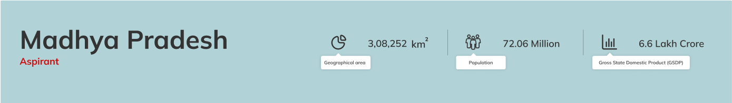

1. The State Statistics can be simpler. We can remove the state outline image.
2. Please use the same icons. On hove, it can mention geographical area, population and GSDP as shown above.

## IEMI Rank

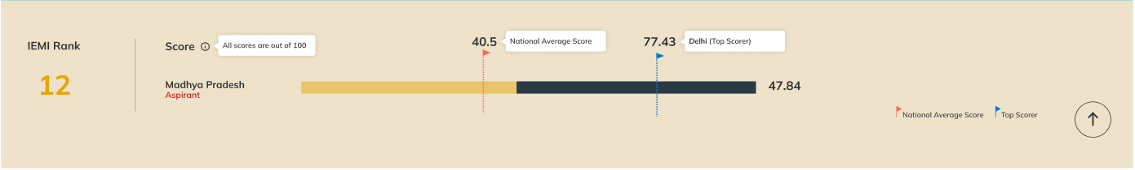

1. IEMI Rank shall not include geographical group rank. We do not need to mention the out of or denominator in ranks.
2. Geographical group average score is not required. Top scorer can be shown as a flag.
3. The background colours, flag colours and performance of state colours must be matched.

## Themes

1. 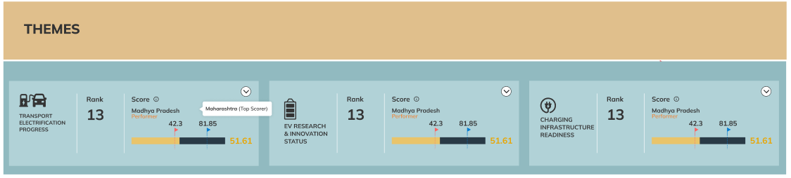The themes graph must be placed horizontally.
2. In the theme graphs, rank shall not include geographical group rank. We do not need to mention the out of or denominator in ranks.
3. Geographical group average score is not required. Top scorer can be shown as a flag.
4. Colours must be matched.

## Indicators Rank and Score

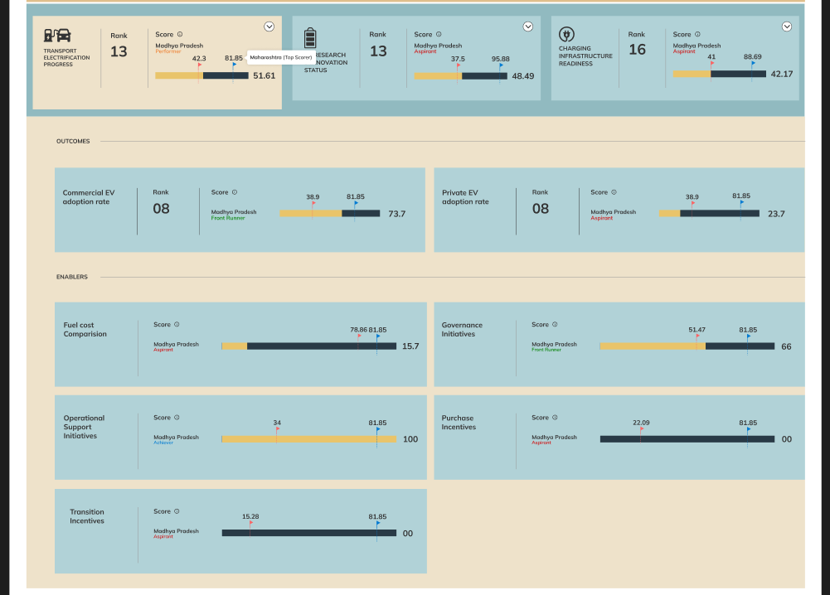

1. On clicking themes, the themes must show be highlighted and the indicators below them must be shown in a layout as indicated below.
2. For any indicator, geographical rank is not required. We do not need to mention out of or denominator in rank.
3. Please match layout colours.
4. Geographical group average score is not required. Top scorer can be shown as a flag.

## Navigation Pane

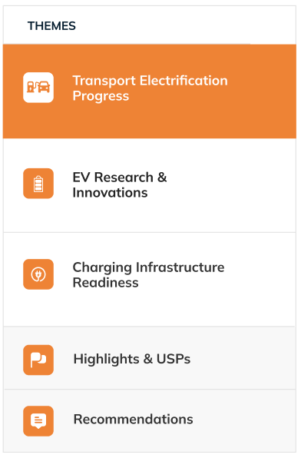

1. Please include icons and highlighted font colour change.

## Transport Electrification Progress – Outcomes

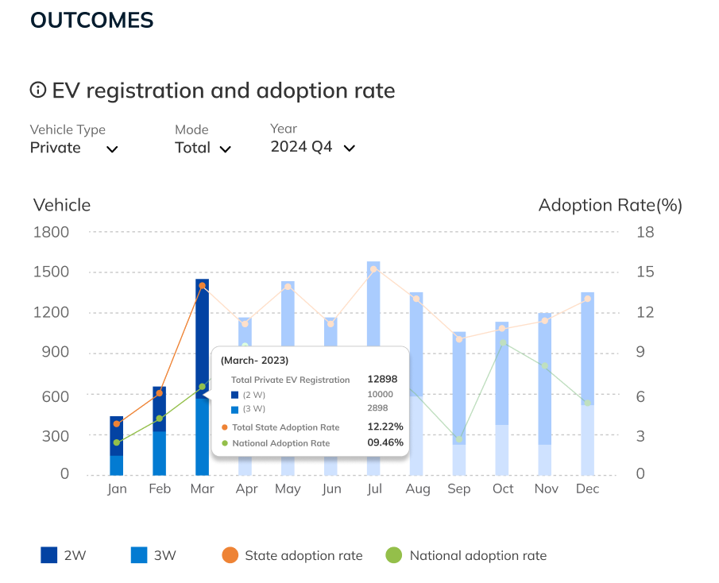

1. For EV Registration and adoption rate, by default, the mode will always be selected as “Total” so that the user can view the stacked bar graph depicting the different vehicle type’s data.
2. Show State adoption rate and National adoption rate in the graph in the secondary y axis.
3. Please highlight the quarter based on the quarter selected on the graph.
4. Please add the info icon as shown in the image.
5. Please show the information as indicated in the hover.
6. Show month and year in the x axis in MMM YYYY format – Jan 2024.

## Transport Electrification Progress – Initiatives

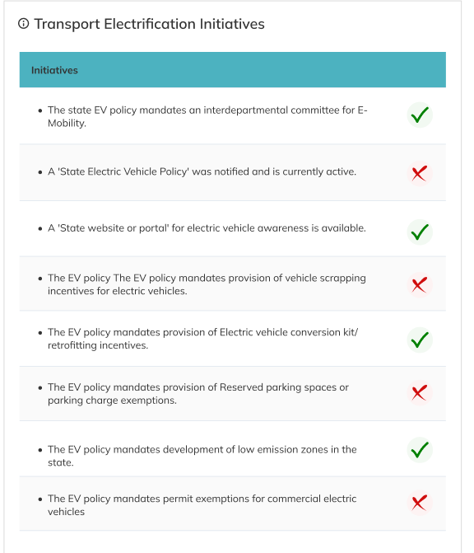

1. Please add the info icon.
2. Match the header colour.

## Transport Electrification Progress – Purchase Incentives

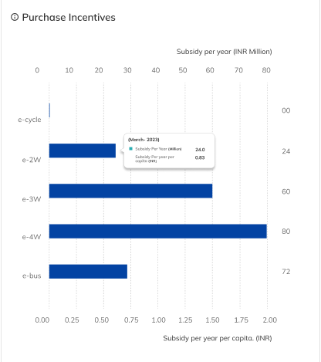

1. Please include information icon.
2. Since the subsidy per year and subsidy per year per capita is linear, please show the secondary y axis as shown.
3. Please include the units as indicated.
4. Please include information as indicated in the hover.

## Units of electricity at cost of petrol

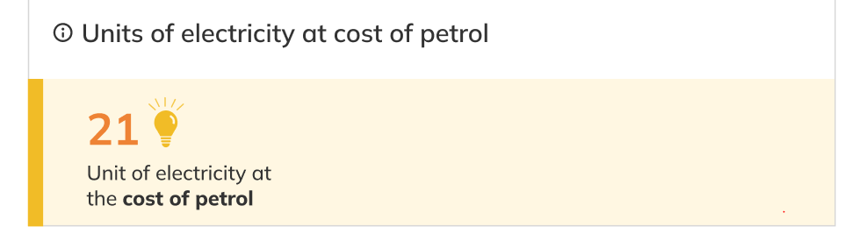

1. Add info icon.
2. Simplify the visualization.

## EV Research and Innovation Theme

1. Replace “EV Industry Status” with “EV Research & Innovation Status”

## EV Research and Innovation Theme - Outcome

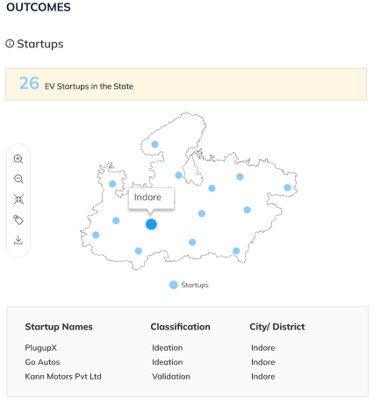

1. Info icon shall be included as indicated.
2. Manufacturing units map shall be moved to the tools and analysis section.
3. Rename Manufacturing Units and Startups to ‘Startups’.
4. The Startup data can be shown in the map.
5. The number of startups can be shown as indicated above the map.
6. In the map, we can use the icon to zoom in and zoom out. Scroll is not required.
7. The startup information shall be shown below the map by clicking on any specific city.
8. Icon size can be based on the number of startups in the city.

## EV Research and Innovation Theme – Initiatives

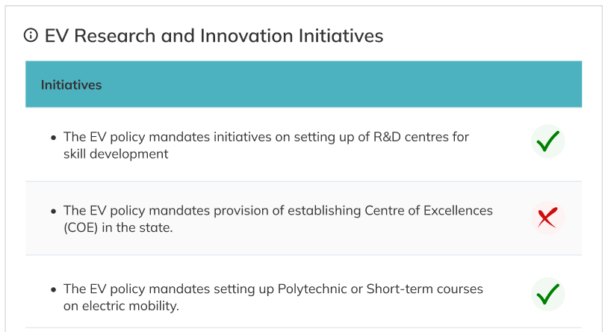

1. Include the information icon.
2. Rename to EV Research and Innovation Initiatives.
3. Change the initiative title colour as indicated in blue.

## Charging Infrastructure Readiness – Outcomes

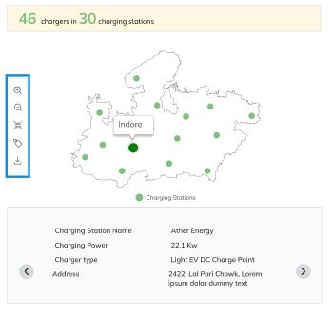

1. Info icon shall be included as indicated.
2. The number of ‘chargers in charging stations’ can be shown as indicated above the map.
3. In the map, we can use the icon to zoom in and zoom out. Scroll is not required.
4. The information on charging stations can be shown as indicated in above map.

## Charging Infrastructure Initiatives

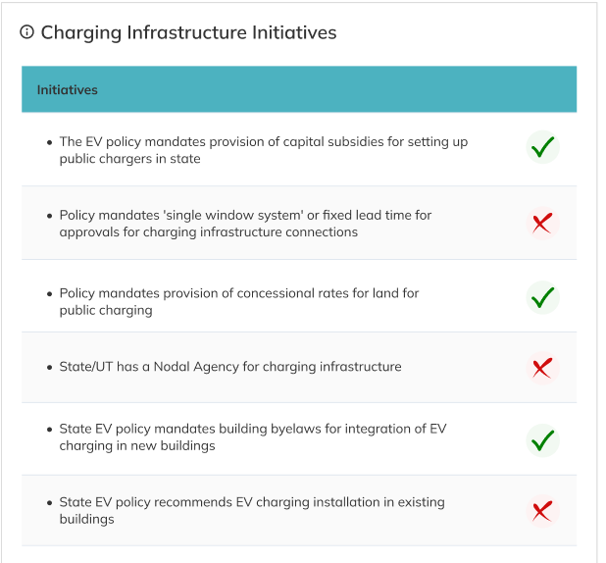

1. Add info icon.
2. Match header row colour.

## Total Renewable Energy and its share

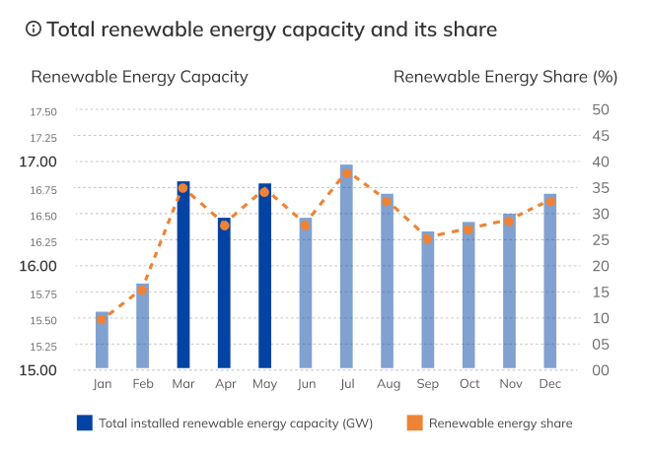

1. We can have a dynamic y axis limits set based on the values of the renewable energy capacity.
2. X axis in MMM YYYY format.

## Power deficit

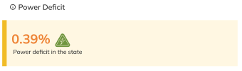

1. Info icon must be included.
2. This is a new indicator added to the index.

## Highlights and USPs

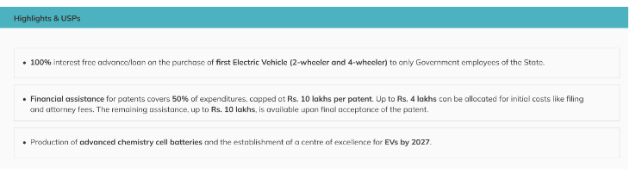

1. Match the header colour.
2. Remove “as per state EV policy”.
3. The content mentioned in this section needs to be highlighted with data points as required by the Admin. To achieve this, we can use “RichTextEditor” to generate the format of the content as required.

## Recommendation section

1. Use the colour as indicated for the header.
2. Each recommendation is connected to a theme hence the same iconology and title with box shall be used to define the same.
3. The content mentioned in this section needs to be highlighted with data points as required by the Admin. To achieve this, we can use “RichTextEditor” to generate the format of the content as required.

# State Comparison Page

## Selection

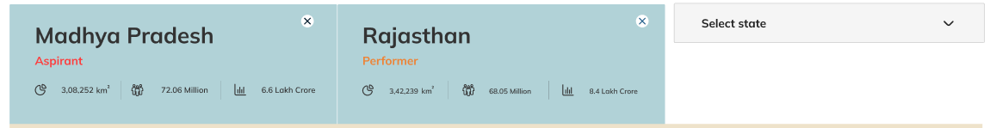

1. The already selected state on the “State Profile” section will be selected as the first state to compare.
2. The user needs to select the other states (1 or 2) as required by the user to compare.
3. The user has the option to compare between 2 states or among 3 states.
4. The user can tap on “x” on the top right corner of each state to cancel the state or change to another state for comparison.

## IEMI Score Comparison Summary

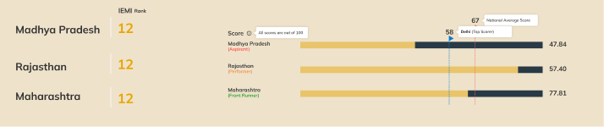

1. Instead of column-based graph, composite graph can be indicated as shown above.
2. Geographical rank is not required.
3. Composite Rank denominator or out of is not required.
4. The Top Scorer shall be shown in flag.
5. Colours of background, text, and flag must be matched.

## IEMI Score Summary sticky bar



1. When the user scrolls to the bottom of the page, then the top section will be sticky and the user only has the option to change the state and time period as and when required.
2. A sticky bar must be shown on top after state selection on scrolling down that includes
   1. State name
   2. Aspirant/Performer/Front Runner
   3. Rank
   4. Score

## IEMI Theme Score Comparison

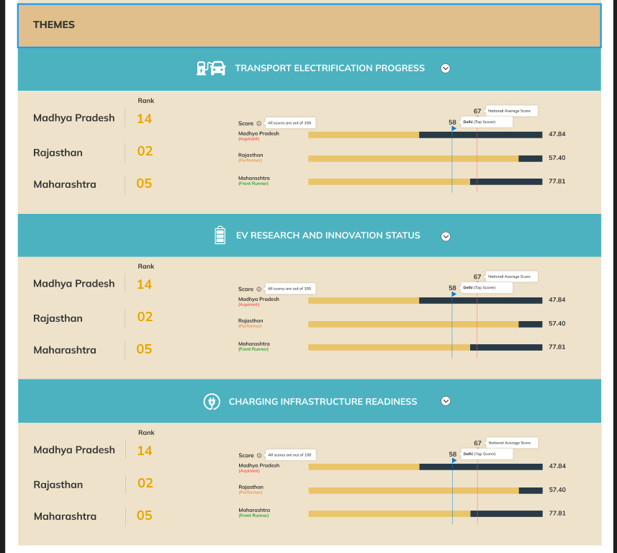

1. Instead of column-based graph, composite graph can be indicated as shown above.
2. Geographical rank is not required.
3. Composite Rank denominator or out of is not required.
4. The Top Scorer shall be shown in flag.
5. Colours of background, text, and flag must be matched.

## Navigation Pane

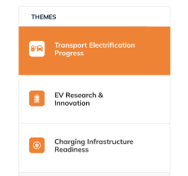

1. Please include icons against each theme.
2. And highlighted font colour can be in white.

## Transport Electrification Progress - Outcome

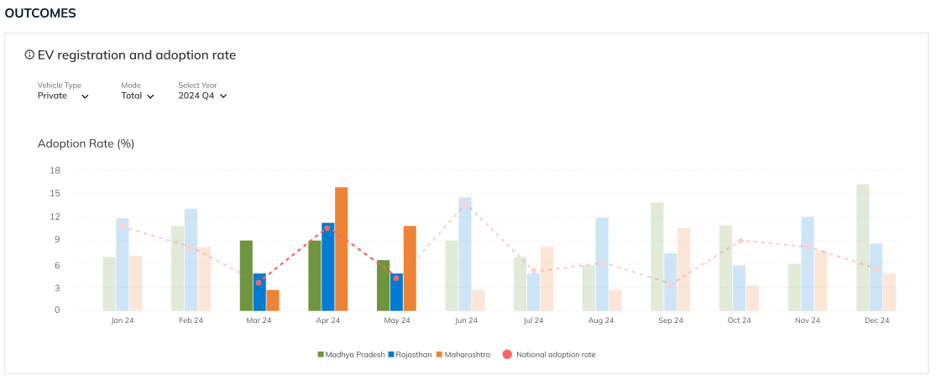

1. Add the info icon on top.
2. Composite graph must be created.
3. For all the bottom sections the data will be as per the State Profile only but only in comparison format.
4. The x axis must be in mmm yyyy format.
5. Each state will have a different color code provided, namely, State 1 - #6F953E; State 2 - #037BD2; State 3 - #EE8335. As and when the state is selected, the color assigned will represent the same state in the graph.

## Transport Electrification Progress - Initiatives

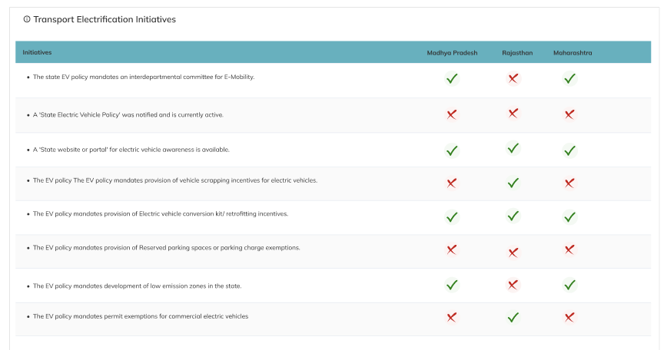

1. Add the info icon on the top.
2. Even the Initiatives of all the Themes will be listed and the one present in the state will be highlighted using green tick otherwise will be highlighted by red cross.
3. The quarter can be highlighted based on the selection.

## Transport Electrification Progress

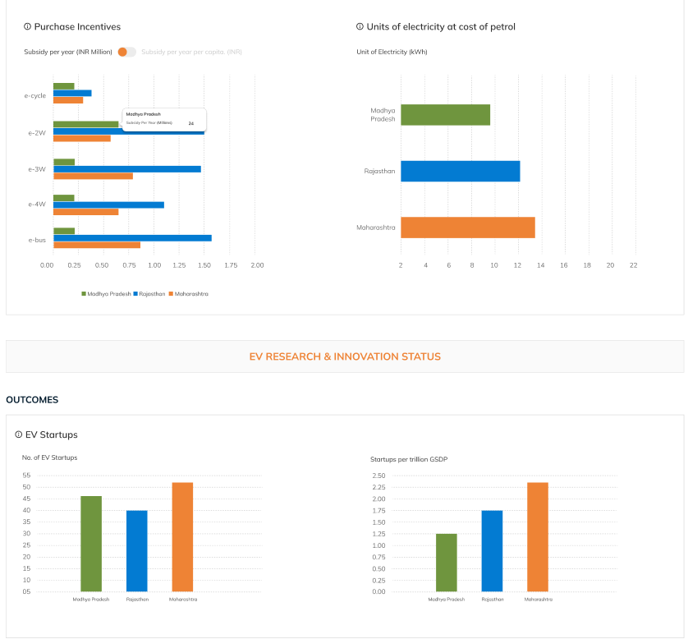

1. Info icons
2. Composite graphs. Use colour scheme as mentioned above.

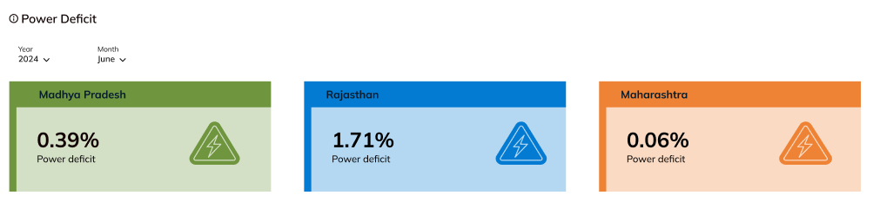

1. Info icons as indicated.
2. New indicator.
3. Data must be added to the database,

# Tools and Analysis Page

## Layout

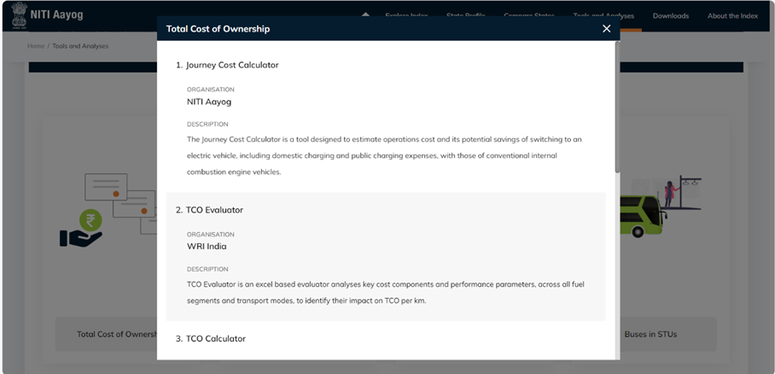

1. When clicked on each card/tool- it should go to a different page, rather than a popout window.
2. Please update the banner.



## Total cost of ownership

1. Use the card as indicated below for total cost of ownership. Please refer to the images shared via mail.

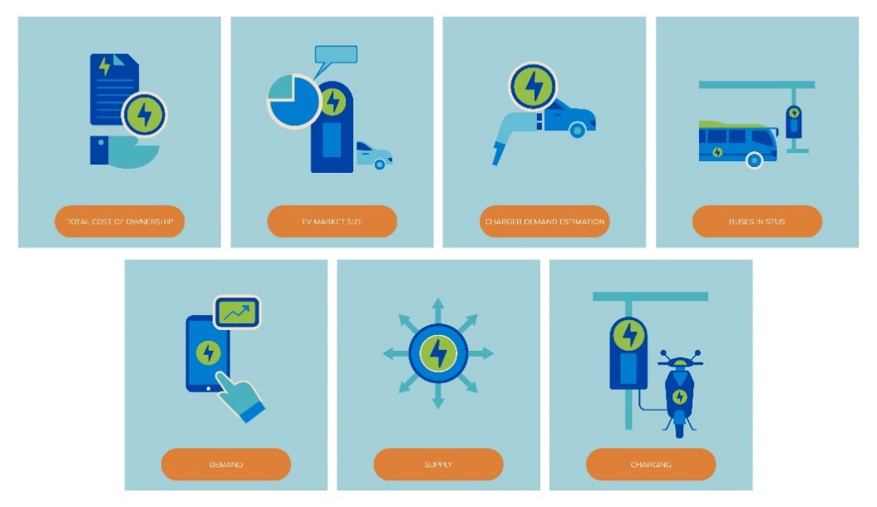

## Manufacturing Units

1. Please use the card as indicated below.



1. The map representing ‘Manufacturing Units’ in the ‘State Profile’ page to be removed and added to the ‘Tools and Analyses’ page. The card can be named as ‘Manufacturing Units’. Please update EV Market Size Card.

## Electric Vehicle Market Insights

1. Use the Card Below for EV Market Insights



1. Please update EV Market Size Card. Please rename EV Market Size to 'Electric Vehicle Market Insights'. All the links and details are tabled below:

|  |  |  |  |
| --- | --- | --- | --- |
| **Sl. no.** | **Organisation** | **Link** | **Description** |
| 1 | International Energy Agency (IEA) | [Global EV data Explorer](https://www.iea.org/data-and-statistics/data-tools/global-ev-data-explorer) | The Global EV Data Explorer showcases comprehensive historical and projected data on electric vehicle (EV) sales, stock, charging infrastructure, and oil displacement. Supported by the Electric Vehicles Initiative (EVI), it allows users to delve into the Global EV Outlook, an annual report analyzing developments in electric mobility worldwide. |
| 2 | Council on Energy, Environment and Water (CEEW) | [EV National Volume Monitor](https://www.ceew.in/cef/tools_and_dashboards/electric-mobility/national-volume-monitor) | The EV National Volume Monitor tracks and presents historical data pertaining to electric vehicle statistics. Users can utilize the dashboard, which offers options like vehicle categories and financial years, to analyze monthly performance breakdowns. |
| 3 | OMI Foundation | [EV Sales - EV Ready India](https://evreadyindia.org/ev-sales/) | The EV sales forecast from EV Ready India offers three forecast ranges: normal, lower, and upper. It also incorporates adjustments to accommodate current macroeconomic trends and government support at both central and state levels. The sales forecast is generated using the Meta Prophet model. |
| 4 | Climate Dot in collaboartion with Climate Trends | [The e-mobility dashboard](https://climatedot.org/dashboard/e-mobility) | The e-mobility dashboard provides extensive data on nationwide EV sales, covering two, three, and four-wheeler categories, as well as electric buses. By sourcing real-time data from the Indian Government's Vahan dashboard, it facilitates detailed comparisons of vehicle sales among states, annual EV sales trends since 2014, and the adoption of EVs across states and throughout India across all vehicle categories. |
| 5 | Ministry of Road Transport & Highways (MoRTH), Government of India | [Vaahan Dashboard](https://vahan.parivahan.gov.in/vahan4dashboard/vahan/view/reportview.xhtml) | The Vahan dashboard, developed and maintained by the government, is a vehicle registration platform that monitors and presents vehicles categorized by fuel type, mode type, norms, vehicle category, vehicle class, and maker. Users can utilize the dashboard to monitor the trend of vehicle registrations on a monthly basis. |

## Electric Vehicle Charging Tools

1. Please use the card below.



1. Please update Charger Demand Estimation Card. Please rename Charger Demand Estimation to **'Electric Vehicle Charging Tools'**. All the links and details attached in the links provided in the UAT Sheet. Attaching details of various EV charging tools below:

|  |  |  |  |
| --- | --- | --- | --- |
| **Sl. no.** | **Organisation** | **Link** | **Description** |
| 1 | International Energy Agency (IEA) | [Electric Vehicle Charging and Grid Integration Tool](https://www.iea.org/data-and-statistics/data-tools/electric-vehicle-charging-and-grid-integration-tool) | The EV Charging and Grid Integration Tool serves as a companion to the policy makers to deliver quantitative estimates.The tool enables the users to assess the impact of electric mobility strategies on power grids and the corresponding emission under a range of circumstances relevant for the countries under the Global Electric Mobility Programme (GEF). |
| 2 | NITI Aayog | [Home Charging Calculator](https://e-amrit.niti.gov.in/home-charging-calculator) | The Home Charging Calculator assists electric vehicle owners in determining the charging time and associated costs for EVs. The tool focuses to assist users who primarily charge electric vehicles at home overnight, leveraging cheaper electricity rates. Users shall provide details such as vehicle segment, state, battery capacity, domestic tariff, and charger specifications to estimate charging costs in comparison to conventional fuel vehicles, considering mileage and distance to be traveled. |
| 3 | NITI Aayog | [Public Charging Calculator](https://e-amrit.niti.gov.in/public-charging-calculator) | The Public Charging Calculator enables users to determine the time and cost required to charge electric vehicles using slow, fast, or rapid chargers at public locations. With inputs such as the vehicle segment, cost per kWh, battery capacity, desired range or battery level, and charger kW, users can estimate both the duration and expenses of charging their electric vehicles at public charging stations. |
| 4 | GO EC Auto tech PVT LTD. | [Home Charging Calculator](https://www.goecworld.com/home-charging-calculator) | Home Charging Calculator is an interactive tool that provides users with a cost estimation for charging electric vehicles at home, facilitating informed decision-making and ensuring financial prudence. By utilizing this calculator, individuals can effectively plan their charging schedules, maintain budgetary constraints, and ultimately enhance their home EV charging experience with ease and confidence. |
| 5 | GO EC Auto tech PVT LTD. | [Public Charging Calculator](https://www.goecworld.com/public-charging-calculator) | Public Charging Calculator is an user-friendly tool empowers to accurately estimate the cost of charging sessions in real-time, enabling strategic decision-making regarding trip routes and budget management. |
| 6 | Connectriq Engineering Services LLP | [EV Charging Time Calculator](https://www.connectriq.in/charging-time-calculator/) | The Charging Time Calculator provides estimates for both AC and DC charging stations. The application uses inputs such as car model, charger capacity, current charge level, and target charging level along with fixed battery capacity and onboard charger details to estimate the charging time. |

## E-Buses in STUs

1. Please use the card below.



1. Update Buses in STUs Card. Please rename as 'E-Buses in State Transport Undertakings'. Please create a thematic map for e-buses and share of e-buses in public transport fleet by STUs. Attaching data for map generation:

|  |  |  |  |  |
| --- | --- | --- | --- | --- |
|  | Own fleet | | Hired fleet | |
| State | Total | E-buses | Total | E-buses |
| Andaman & Nicobar Islands | 276 | 0 | 38 | 24 |
| Andhra Pradesh | 8385 | 0 | 2633 | 64 |
| Arunachal Pradesh | 377 | 0 | 10 | 0 |
| Assam | 877 | 15 | 0 | 0 |
| Orissa | 30 | 0 | 310 | 50 |
| Bihar | 552 | 0 | 6 | 25 |
| Chandigarh | 570 | 0 | 0 | 80 |
| Delhi | 0 | 0 | 3413 | 94 |
| Delhi | 3637 | 2 | 0 | 300 |
| Haryana | 2956 | 75 | 28 | 0 |
| Jammu and Kashmir | 727 | 40 | 0 | 0 |
| Goa | 498 | 20 | 0 | 51 |
| Kerala | 5329 | 50 | 122 | 0 |
| Mizoram | 29 | 0 | 0 | 0 |
| Nagaland | 177 | 0 | 0 | 0 |
| Puducherry | 140 | 0 | 0 | 0 |
| Sikkim | 94 | 0 | 0 | 0 |
| Telangana | 6904 | 0 | 2950 | 40 |
| Tripura | 27 | 0 | 0 | 0 |
| Uttarakhand | 900 | 0 | 350 | 0 |
| Uttar Pradesh | 0 | 0 | 0 | 25 |
| Gujarat | 8144 | 0 | 1077 | 208 |
| Maharashtra | 19093 | 36 | 2765 | 1251 |
| Tamil Nadu | 16841 | 0 | 0 | 0 |
| Karnataka | 23409 | 0 | 0 | 440 |
| Uttar Pradesh | 8643 | 40 | 2386 | 675 |
| Rajasthan | 3073 | 0 | 100 | 0 |
| West Bengal | 3009 | 5 | 0 | 0 |
| Punjab | 2823 | 0 | 251 | 0 |

# Downloads

1. Please use the banner as shown below.



# About the index

1. Please use the banner as indicated below.



IEMI Structure section:

1. Replace ‘EV Industry status’ theme to ‘EV Research and Innovation’ theme.
2. Remove ‘EV manufacturing capacity’, ‘Capital subsidies for EV initiatives’ and ‘Land and infrastructure initiatives’ parameter from theme 2.
3. Add parameters ‘EV Research and Development Initiatives’
4. Replaced the parameter names as per the table attached and create a chart like below:

|  |  |  |  |
| --- | --- | --- | --- |
| **Theme name** | **Parameter type** | **Parameter type** | **Parameters** |
| **Transport Electrification Progress** | **1** | Outcomes | Private Electric Vehicle Adoption Rate |
|  |
|  |
|  |
| **2** | Outcomes | Commercial Electric Vehicle Adoption Rate |  |
|  |
|  |
|  |
|  |
|  |
|  |
|  |
|  |
|  |
|  |
|  |
| **3** | Enablers | Governance initiatives |  |
|  |
|  |
| **4** | Enablers | Purchase Incentives |  |
|  |
|  |
| **5** | Enablers | Transition Initiatives |  |
|  |
| **6** | Enablers | Operational support initiatives |  |
|  |
|  |
| **7** | Enablers | **Fuel Cost Comparision** |  |
|  |
| **Charging Infrastructure Readiness** | **8** | Outcomes | **EV to EV Charger Ratio** |  |
|  |
| **9** | Enablers | Capital subsidies for charging infrastructure |  |
| **10** | Enablers | Charging Infrastructure Development Initiatives |  |
|  |
|  |
| **11** | Enablers | Building Bylaws (and mandates) |  |
|  |
| **12** | Enablers | **Share of Renewable Energy Generation Capacity** |  |
|  |
| **13** | Enablers | **Power Availability** |  |
|  |
| **EV Research and Innovation Status** | **14** | Outcomes | **EV Startups** |  |
|  |
| **15** | Enablers | EV Research and Development Initiatives |  |
|  |
|  |
| **16** | Enablers | **EV-related patents** |  |

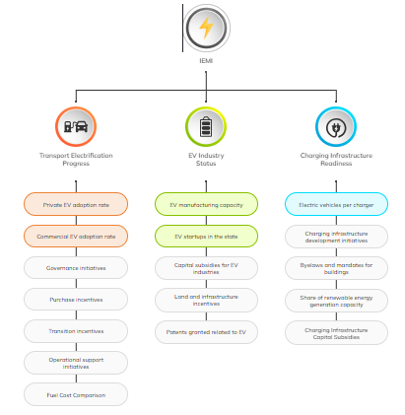

1. Replace the text ‘There are 17 performance indicators (parameters) within the themes, categorized as enablers and outcomes’.
2. Replace Theme 2 name to ‘EV Research and Innovation’ in below figure:

